Threat Hunter Introduction to SI — Lesson Plan
Classification: UNCLASSIFIED

1. Administrative and metadata

1.1 Lesson title
Threat Hunter Introduction to SI

1.2 Module length
120 minutes (2 hours)
Schedule slot is 120 minutes. Content-guide ~3 hours plus a 30-minute lab transition is the longer narrative.

1.3 Terminal and enabling learning objectives
- TLO-5: At the end of the Counterstrike Operator Course, students will be able to use local inference and agentic workflows to support hunting and planning, and counter adversary agentic systems.
- ELO-67: Describe how large language models, local inference, and OpenAI-compatible APIs can support threat hunting and tactical planning analysis.
- ELO-68: Identify the limits of SI-generated leads and the requirement to verify them against primary evidence.

1.4 Prerequisites
- B01.M09: Military Tactical Planning
- B01.M23: MITRE D3FEND and ENGAGE

2. Personnel, range, and environment

2.1 Instructor and cadre
- 1 × instructor (required)
- 0 × range_engineer (not_applicable: Lecture Module; no range engineer required)
- 0 × auditor (not_applicable: Not used by this course)
- 0 × oversight_officer (not_applicable: Not used by this course)

2.2 Materials and resources
Instructor resources and pre-class preparation
- Classroom projector and screen; whiteboard for local-vs-external and evidence-vs-draft
- Live tabs only as references: Ollama, Open WebUI, vLLM, Hugging Face, Docker GPU, NVIDIA Container Toolkit
- Token bundle stays with the instructor; do not project API credentials
- Planning vocabulary and ATT&CK/D3FEND/ENGAGE framing already in the room
Student resources and environment
- Student workstations for discussion
- No additional student kit for the lecture
- Lab-safe synthetic examples only; no real operational data in prompts

3. Assessment and evaluation
ELO | Method | Related Module | Criteria
ELO-67 | in-class Q&A | — | Students describe how LLMs, local inference, and OpenAI-compatible APIs support hunt and planning analysis.
ELO-68 | in-class Q&A | — | Students identify limits of SI-generated leads and the requirement to verify them against primary evidence.

4. Instructional delivery

4.1 Opening, attention grabber, and motivator

Option 1 (Interactive / Whiteboard / Kinesthetic)
- Say: "This block is for threat hunters, not ML researchers. You need to understand enough to use the tool, challenge the tool, deploy the tool, and explain the risk to a commander."
- Do: Draw staff-assistant vs authority on the board. Label: model drafts; operator owns evidence, source validation, confidence, and the recommendation.
- Ask (Q): Where have you already seen SI in your workflow?
- Expected Response (A): Facilitation. EDR summaries, query copilots, ticket summarization, code generation, report drafting, or adversary automation.

Option 2 (Digital Slide / Virtual / Slide Deck)
- Say: "This block is for threat hunters, not ML researchers. You need to understand enough to use the tool, challenge the tool, deploy the tool, and explain the risk to a commander."
- Show: The module learning objectives from the source document.
- Do: Ask the room where they have already seen SI in their workflow.
- Ask (Q): Where have you already seen SI in your workflow?
- Expected Response (A): Facilitation. EDR summaries, query copilots, ticket summarization, code generation, report drafting, or adversary automation.

4.2 Side-by-side table of instruction
Visual / Slide Asset | Instructional Delivery & Instructor Notes
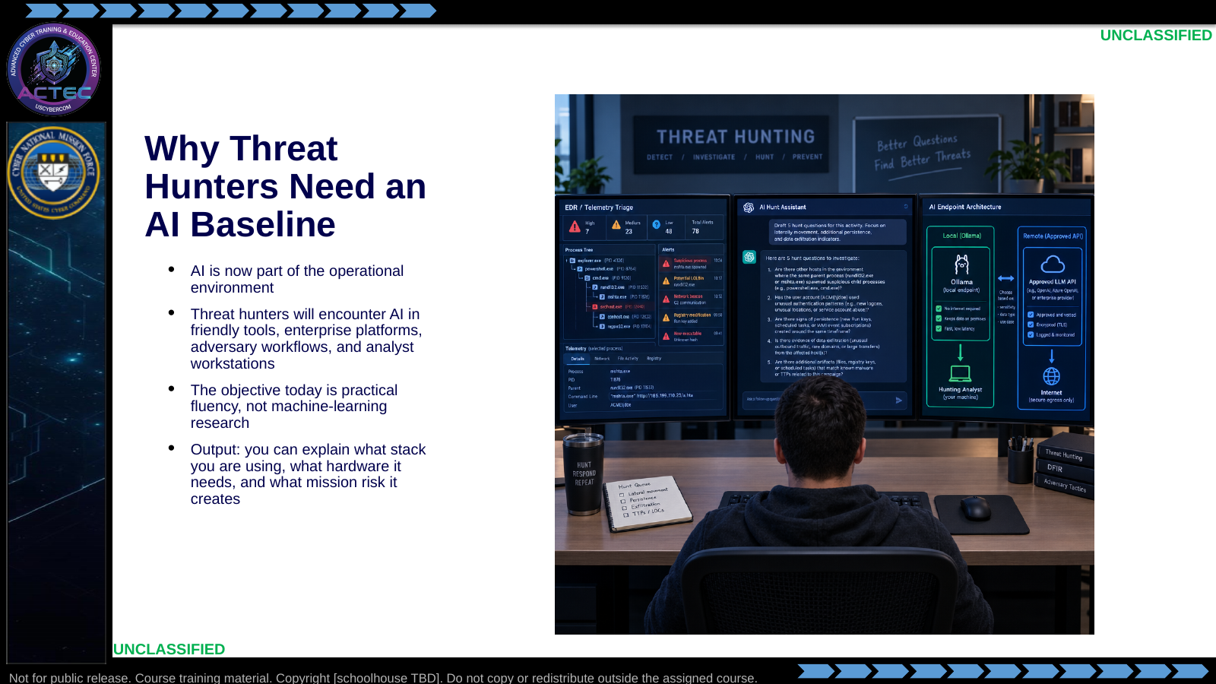  Slide 1: Why Threat Hunters Need a SI Baseline  Duration: 6 min | Say: "This block is for threat hunters, not ML researchers. You need to understand enough to use the tool, challenge the tool, deploy the tool, and explain the risk to a commander."  Show: The module learning objectives from the source document.  Do: Ask the room where they have already seen SI in their workflow: EDR summaries, query copilots, ticket summarization, code generation, report drafting, or adversary automation.  Ask (Q): Where have you already seen SI in your workflow?  Expected Response (A): Facilitation. EDR summaries, query copilots, ticket summarization, code generation, report drafting, or adversary automation.
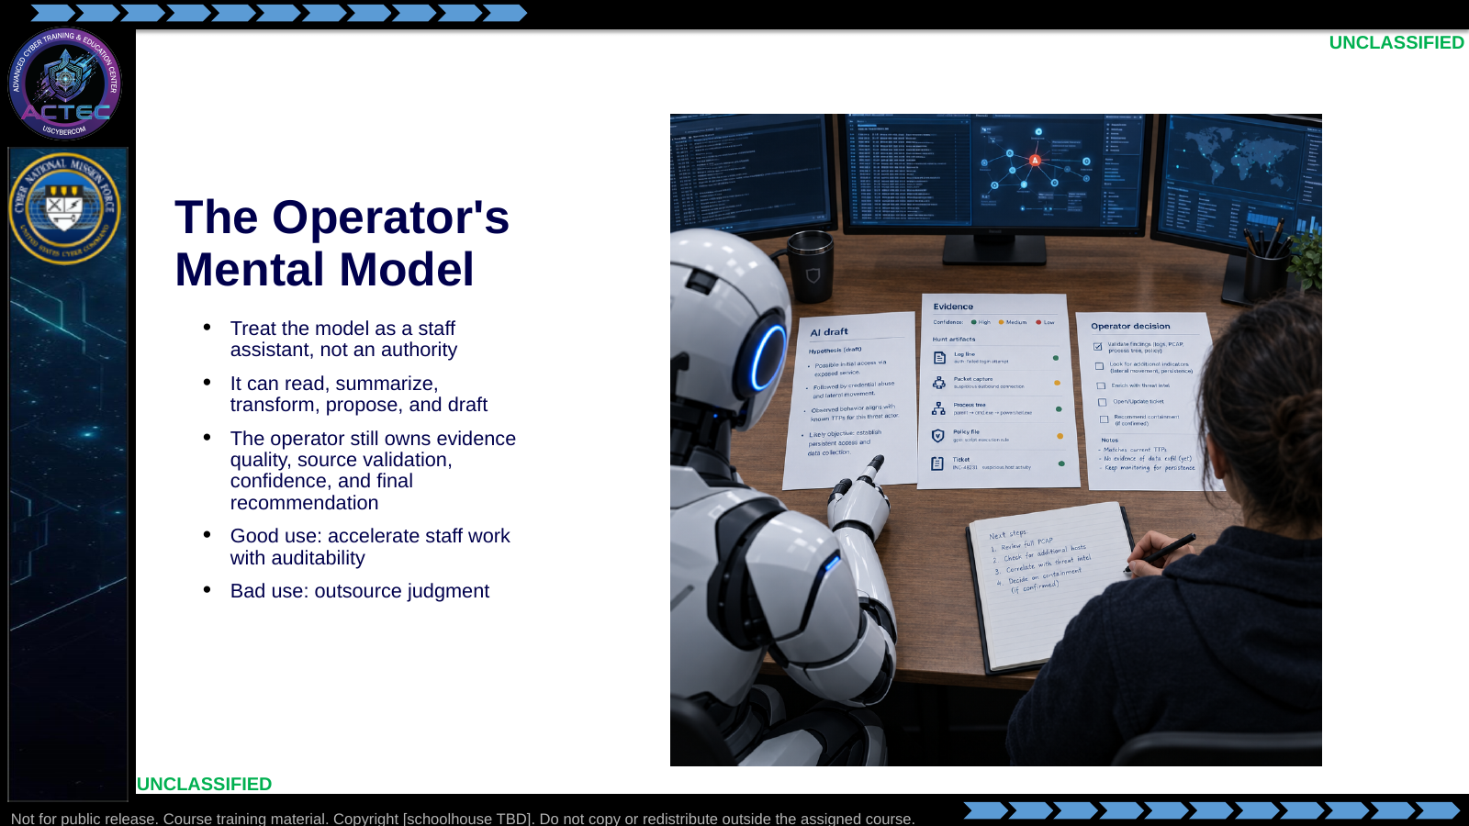  Slide 2: The Operator's Mental Model  Duration: 6 min | Say: "If the model says something useful, that is not evidence. Evidence is still the log line, packet capture, process tree, policy file, image, report, or ticket. The model helps you move faster between evidence and a usable artifact."  Show: A before/after workflow: raw telemetry -> analyst triage -> draft hypothesis -> review -> handoff.  Do: Have students name one SI-supported task that should still require human review. Capture three examples.  Ask (Q): Name one SI-supported task that should still require human review.  Expected Response (A): Facilitation. Capture three examples. The model is not evidence.
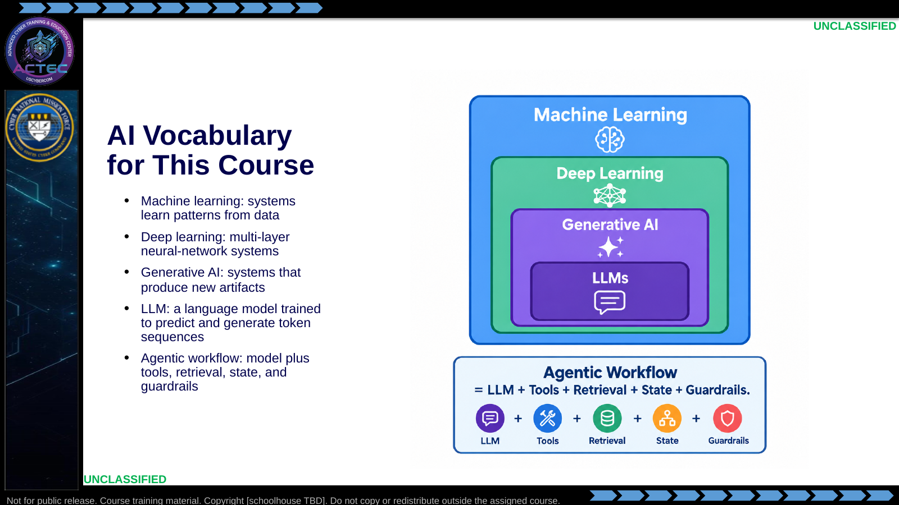  Slide 3: SI Vocabulary for This Course  Duration: 6 min | Say: "This course uses Super Intelligence (SI) for the systems often called artificial intelligence (AI). Executive Order 14434 directs that wording. The systems are the same ones defined as artificial intelligence in 15 U.S.C. § 9401(3). Do not let vocabulary make this mystical. We care about what the system can do, what inputs it sees, what outputs it produces, and what controls keep it inside mission boundaries."  Show: The nested vocabulary diagram.  Do: Ask students to distinguish "LLM" from "agent" in one sentence. Correct gently: the model predicts text; the agent workflow gives that model tools, memory, and process.  Ask (Q): Distinguish LLM from agent in one sentence.  Expected Response (A): The model predicts text. An agent workflow gives that model tools, memory, and process.
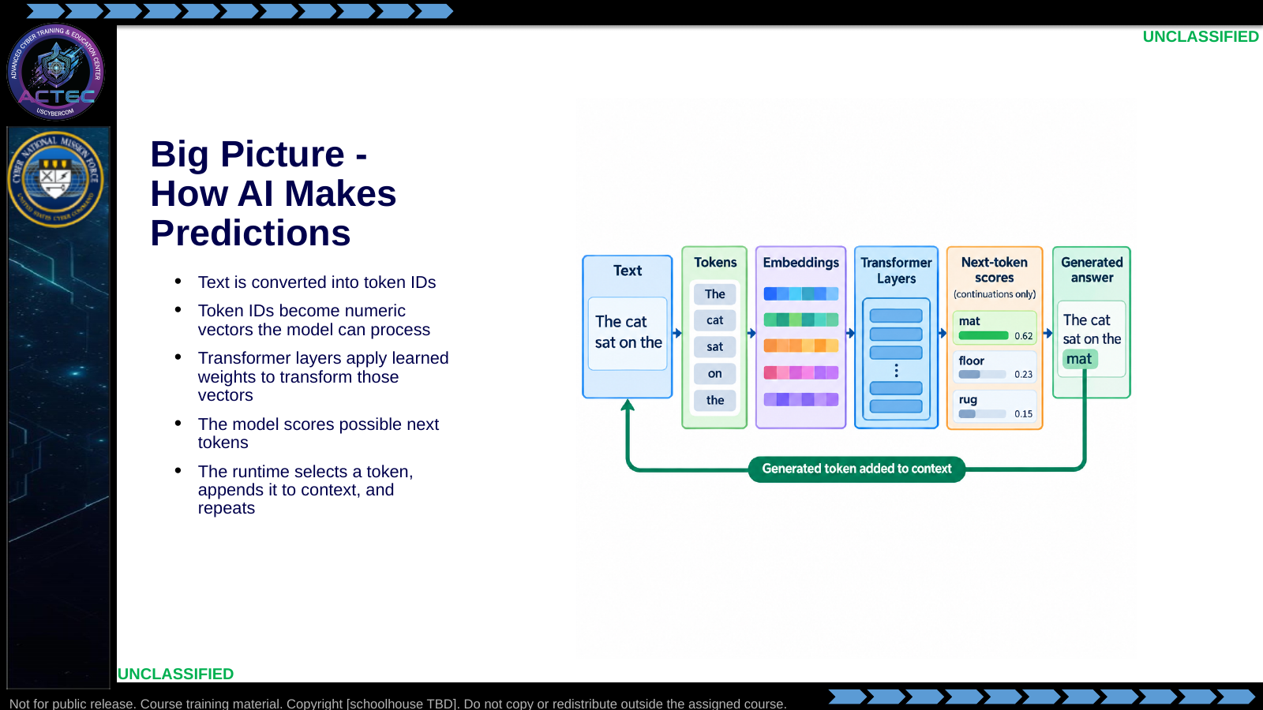  Slide 4: Big Picture - How SI Makes Predictions  Duration: 6 min | Say: "At the big-picture level, an LLM is a prediction system. It turns text into tokens, turns tokens into numbers, applies learned weights across many layers, scores possible next tokens, chooses one, and repeats. The conversational behavior emerges from that repeated prediction loop."  Show: A simple sentence with the next token blank: "The process tree shows winword.exe launched ____." Show several candidate tokens with different scores.  Do: Ask students why the model might choose powershell.exe if the prompt contains office macro and encoded command context.  Ask (Q): Why might the model choose powershell.exe if the prompt contains office-macro and encoded-command context?  Expected Response (A): High-probability continuation from the prompt pattern. That is not proof the event occurred.
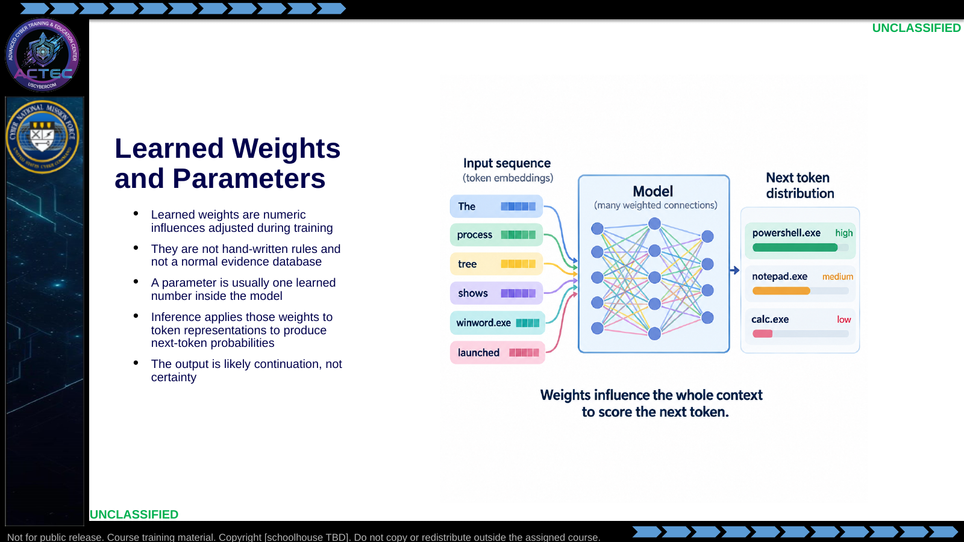  Slide 5: Learned Weights and Parameters  Duration: 6 min | Say: "A learned weight is a number that changes how strongly one signal affects another inside the model. Training adjusts billions of those numbers so the model gets better at predicting tokens. That is why the model can sound authoritative without actually holding evidence in the way a case file holds evidence."  Show: A toy example with three candidate next tokens and scores: powershell.exe high, notepad.exe medium, calc.exe low, based on the surrounding evidence.  Do: Ask students to explain why a high-probability continuation is still not proof that an event occurred.  Ask (Q): Why is a high-probability continuation still not proof that an event occurred?  Expected Response (A): The output is likely continuation, not certainty. Evidence is still the log line, PCAP, or process tree.
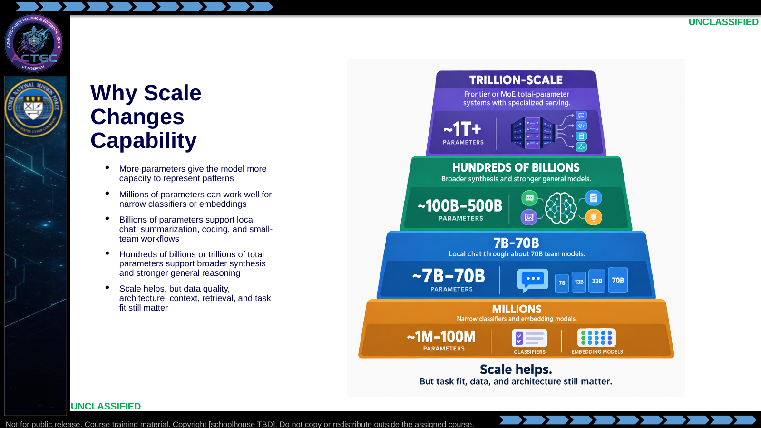  Slide 6: Why Scale Changes Capability  Duration: 6 min | Say: "More parameters means more learned capacity. That is part of why a frontier-scale system can handle broader tasks than a tiny model. But do not turn parameter count into a religion. A small embedding model can beat a huge chat model at embedding, and a smaller model with the right RAG context can beat a larger model that lacks evidence."  Show: A comparison table: small classifier, local 7B/8B chat model, 70B team model, frontier-scale API service.  Do: Give three tasks and have students pick the smallest reasonable class of model: classify log lines, summarize a synthetic incident, synthesize multiple reports into commander guidance.  Ask (Q): For classify-log-lines, summarize-an-incident, and synthesize-commander-guidance, what is the smallest reasonable model class?  Expected Response (A): Facilitation. Narrow classifier vs local chat vs broader synthesis. Parameter count is not a religion.
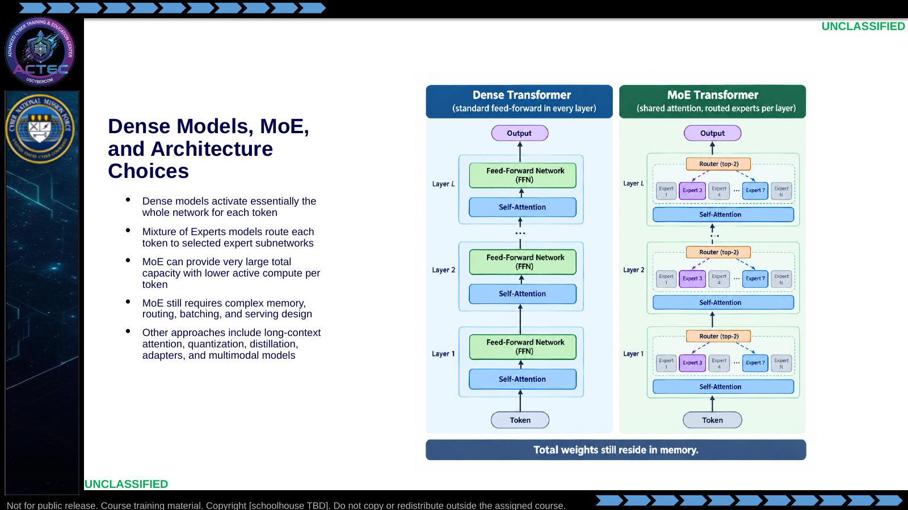  Slide 7: Dense Models, MoE, and Architecture Choices  Duration: 6 min | Say: "Dense means most of the model participates for each token. Mixture of Experts means a router selects which expert subnetworks process a token. That is how a model can advertise a huge total parameter count while only activating part of it per token. It improves scaling, but it complicates serving."  Show: A simple dense vs MoE comparison: total parameters, active parameters, memory residency, batching complexity, and operational fit.  Do: Ask students why a MoE model may still require large memory even if each token only activates a subset of experts.  Ask (Q): Why may a MoE model still require large memory even if each token activates only a subset of experts?  Expected Response (A): Total weights still reside in memory. Routing and batching still need capacity.
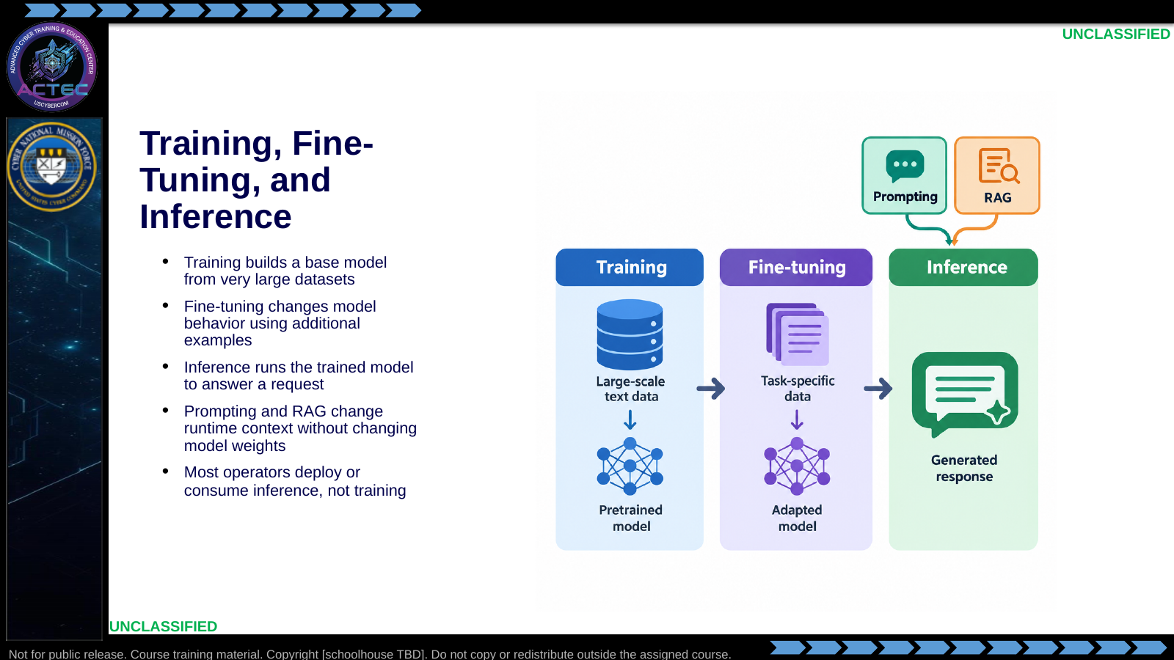  Slide 8: Training, Fine-Tuning, and Inference  Duration: 6 min | Say: "Most of your operational decisions happen at inference time. Which model? Which endpoint? Which prompt? Which evidence? Which token policy? Which logs? You normally are not training a frontier model in the field."  Show: The three-lane diagram.  Do: Ask students whether adding local SOPs to a RAG store is training, fine-tuning, or inference-time retrieval.  Ask (Q): Is adding local SOPs to a RAG store training, fine-tuning, or inference-time retrieval?  Expected Response (A): Inference-time retrieval. RAG does not change model weights.
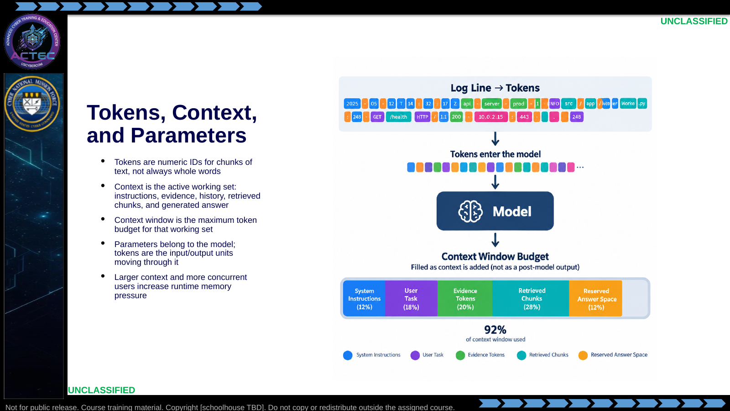  Slide 9: Tokens, Context, and Parameters  Duration: 6 min | Say: "A token is not necessarily a word. It might be part of a word, punctuation, whitespace, or a chunk of an IP address. This is different from the parameters we just discussed: parameters are inside the model; tokens are what move into and out of it. Context is the model's working space. When you paste logs, include chat history, add retrieved chunks, and ask for an answer, all of that spends the same budget."  Show: Example tokenization of a short command line, an IP address, and a log entry. Then show a context budget split into system instruction, user task, evidence, retrieval, and answer.  Do: Have students identify what they would include if the context window allowed only five artifacts from an incident, and what they would intentionally leave out.  Ask (Q): If the context window allowed only five artifacts, what would you include and what would you leave out?  Expected Response (A): Facilitation. Context is a budget. Leave out what does not support the task.
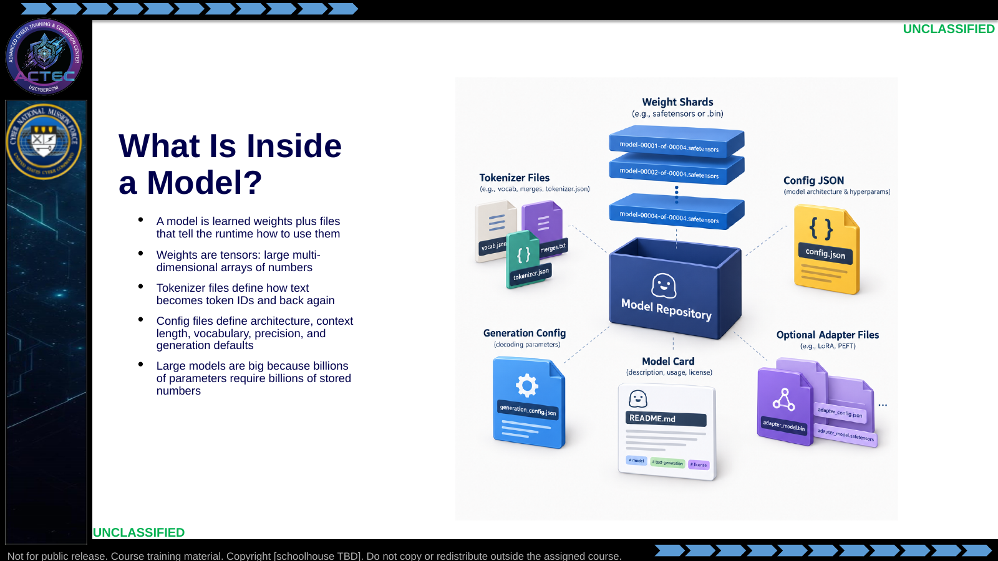  Slide 10: What Is Inside a Model?  Duration: 6 min | Say: "A model is not one magic file. It is usually a set of weight tensors plus the tokenizer and configuration needed to run those tensors correctly. If the tokenizer is wrong, the model is effectively being fed the wrong language."  Show: A generic model repository file list: model-00001-of-00004.safetensors, tokenizer.json, config.json, generation_config.json, README.md.  Do: Ask students why a 7 billion parameter model stored at 16-bit precision is already roughly 14 GB before runtime overhead.  Ask (Q): Why is a 7 billion parameter model at 16-bit already roughly 14 GB before runtime overhead?  Expected Response (A): Billions of stored numbers. 7e9 parameters times 2 bytes is about 14 GB.
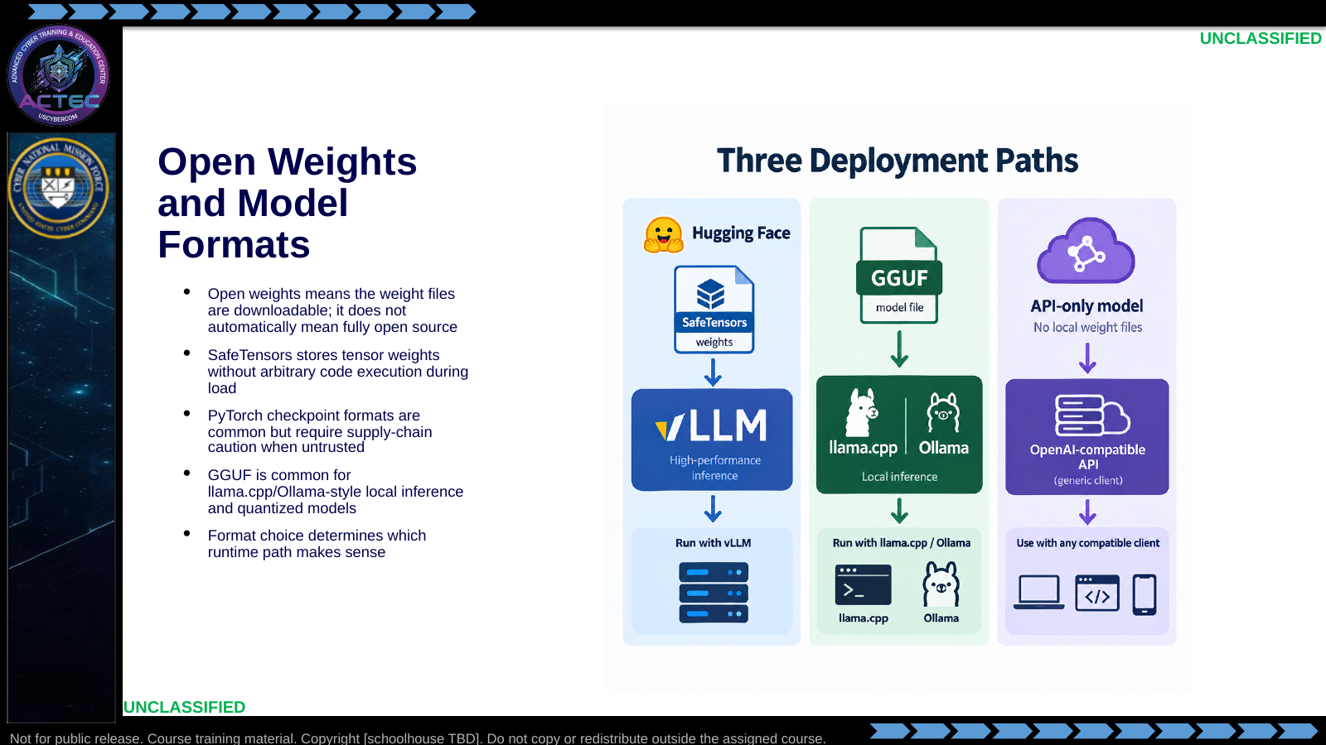  Slide 11: Open Weights and Model Formats  Duration: 6 min | Say: "Open weights means you can download and run the learned weights. It does not guarantee open training data, open training code, or permission for every mission use. Format is also not cosmetic. SafeTensors, GGUF, PyTorch checkpoints, and ONNX are different deployment paths."  Show: A side-by-side table: SafeTensors for Hugging Face/vLLM workflows, GGUF for local quantized inference, PyTorch checkpoints for research/training, ONNX for portable optimized inference.  Do: Ask students what they would document before approving an open-weight model for a team hunt workflow: license, source, format, tokenizer, context length, intended use, and limitations.  Ask (Q): What would you document before approving an open-weight model for a team hunt workflow?  Expected Response (A): License, source, format, tokenizer, context length, intended use, and limitations.
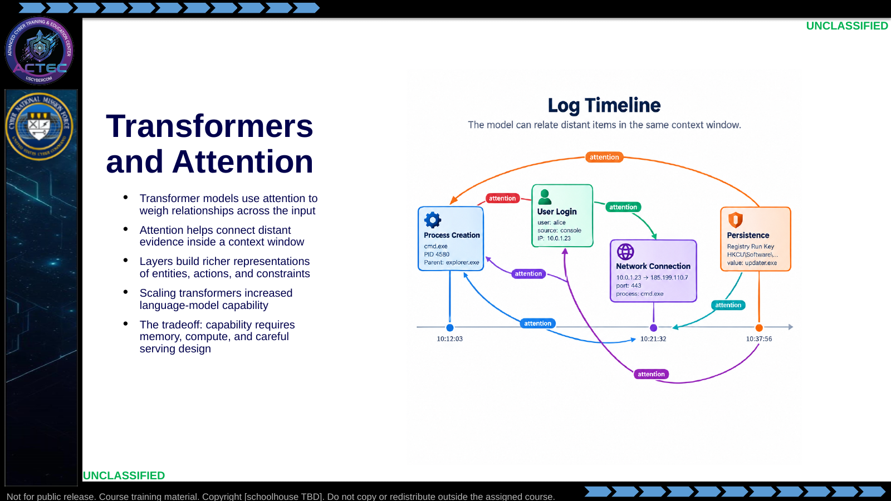  Slide 12: Transformers and Attention  Duration: 6 min | Say: "The operator-level intuition is this: attention lets the model connect things that are far apart in the input. That is why context design matters. The model can only attend to what you give it."  Show: A simple incident prompt with scattered clues; mark the clues the model should connect.  Do: Ask students what happens if the key artifact is omitted from context but the model is still asked for a confident answer.  Ask (Q): What happens if the key artifact is omitted from context but the model is still asked for a confident answer?  Expected Response (A): It will still generate a likely continuation. It can only attend to what you give it.
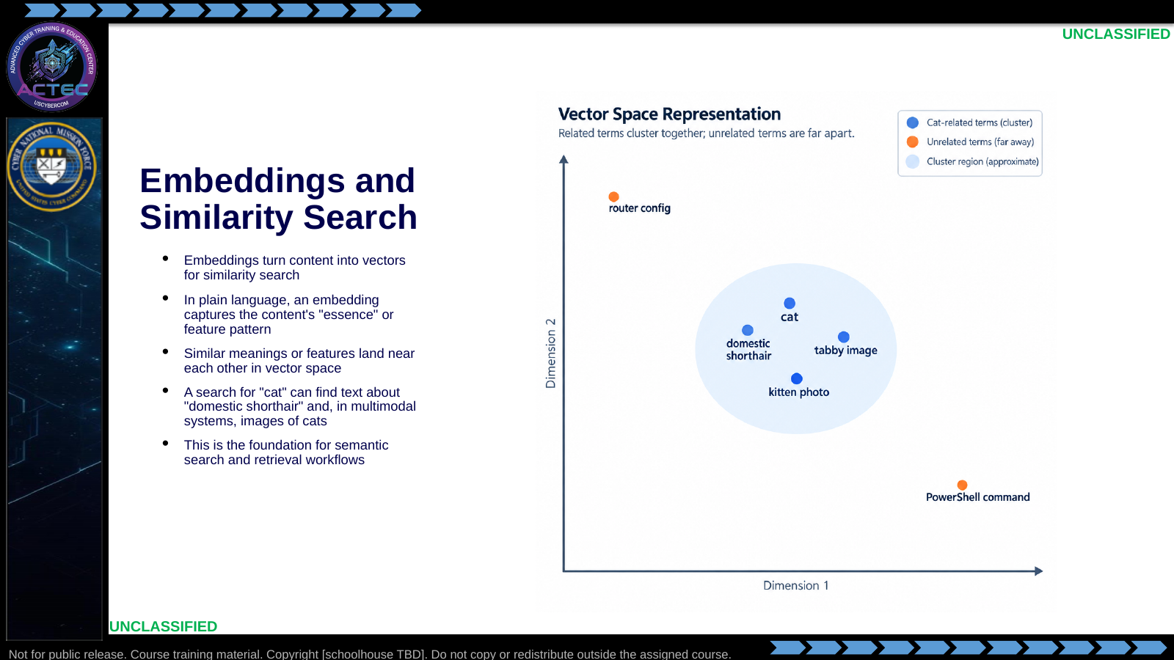  Slide 13: Embeddings and Similarity Search  Duration: 6 min | Say: "Your summary is a good non-technical way to teach embeddings: an embedding captures something like the essence or feature pattern of the input. It is not perfect understanding, but it places similar content close together. So a search for 'cat' can find a document that says 'domestic shorthair' because those concepts are close. In a multimodal embedding system, an image of a cat can also land near cat-related text."  Show: The cat/domestic-shorthair/image cluster in vector space, then a threat-hunting example where encoded PowerShell retrieves notes that say -EncodedCommand and office macro.  Do: Ask students for a security example where exact keyword search would miss a relevant artifact but semantic search could find it.  Ask (Q): Give a security example where exact keyword search would miss an artifact that semantic search could find.  Expected Response (A): Facilitation. Example: encoded PowerShell vs EncodedCommand or office macro.
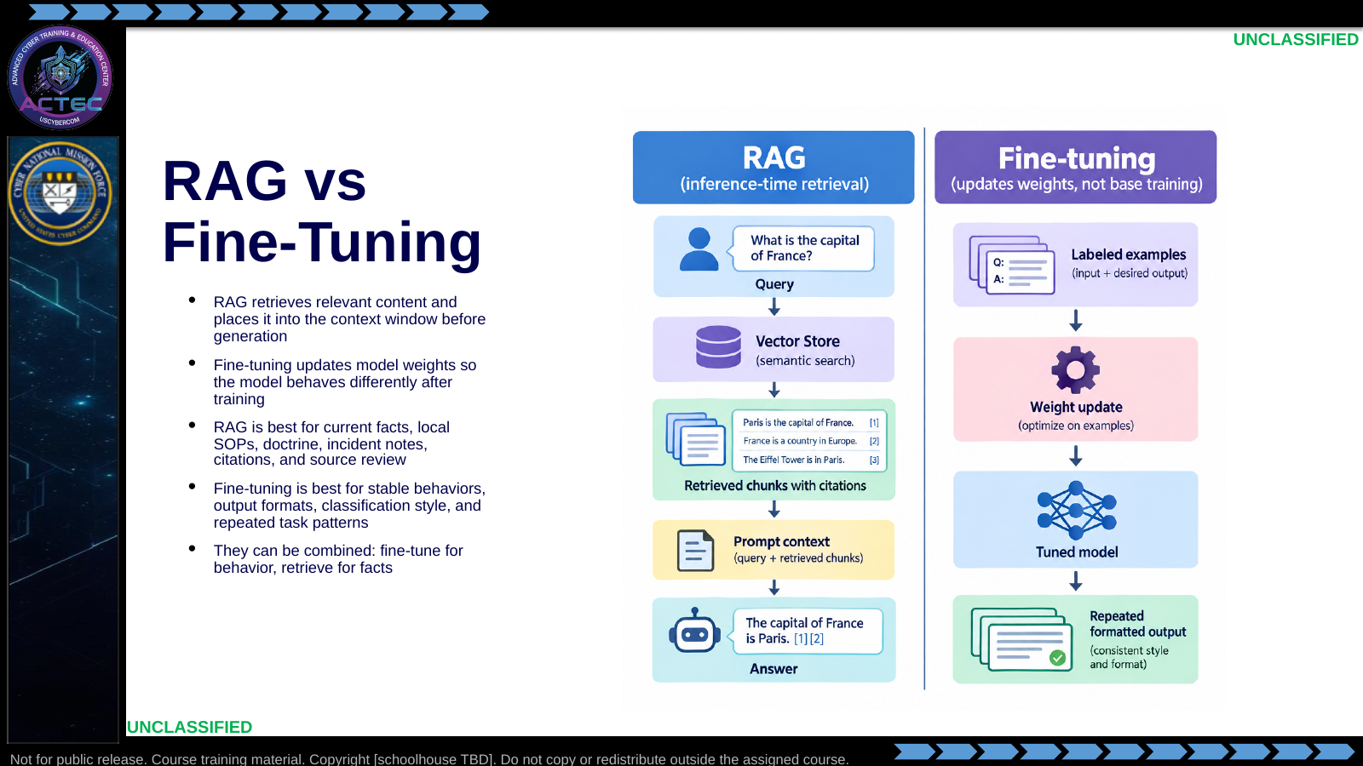  Slide 14: RAG vs Fine-Tuning  Duration: 6 min | Say: "RAG and fine-tuning are both ways to make a model more useful, but they are not interchangeable. RAG changes what the model can reference at runtime. Fine-tuning changes model behavior by updating weights. If you need current SOPs, case notes, and citations, use RAG. If you need the model to reliably follow a stable output pattern across thousands of examples, consider fine-tuning."  Show: A decision table: Need current facts or citations = RAG; Need stable behavior or format = fine-tuning; Need both = tuned behavior plus retrieved evidence.  Do: Give three cases and ask the class to choose RAG, fine-tuning, or both: current incident reports; standardized commander update format; malware-family classification from a labeled training set.  Ask (Q): For current incident reports, a standardized commander-update format, and malware-family classification from a labeled set, choose RAG, fine-tuning, or both.  Expected Response (A): Current reports = RAG. Stable format = fine-tuning. Labeled classification = fine-tuning or both.
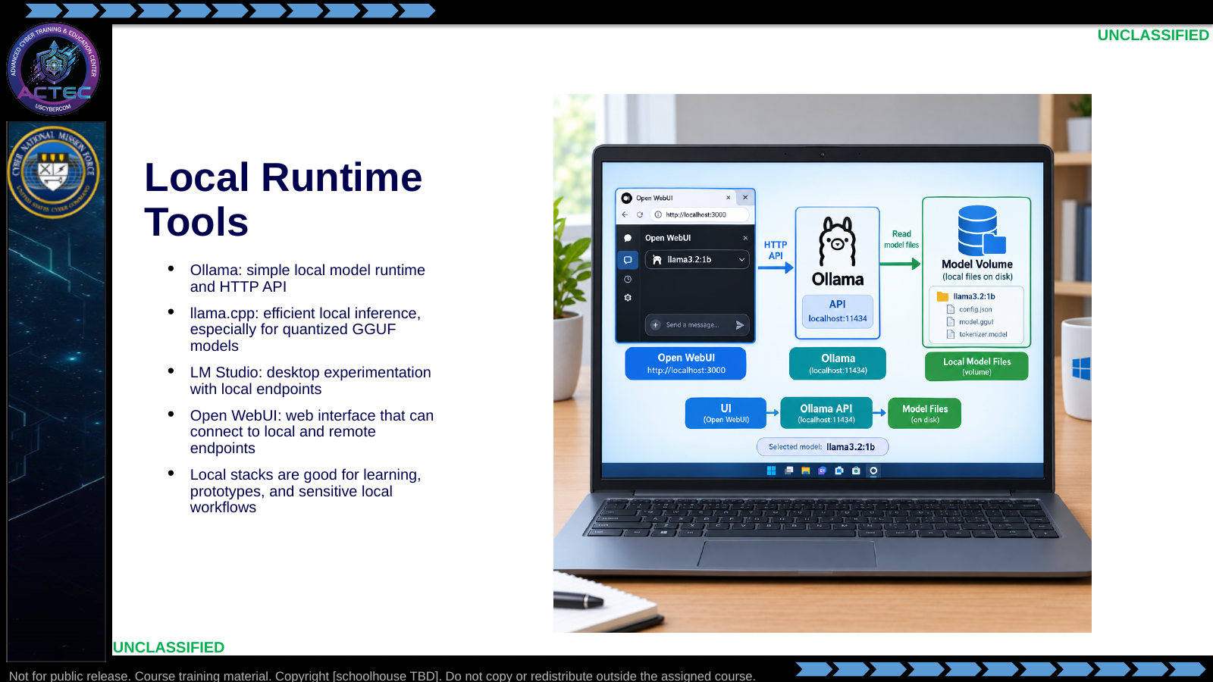  Slide 15: Local Runtime Tools  Duration: 6 min | Say: "Local tools are how you will get hands-on today. They are also a serious operational pattern when data cannot leave the enclave or when the team needs a deployable analyst-assist node."  Show: The lab architecture: Windows + Docker Desktop + Ollama + Open WebUI.  Do: Preview the lab command flow without executing it yet.  Ask (Q): Which local tools will you use in today's lab, and do we execute them during this lecture?  Expected Response (A): Ollama plus Open WebUI on Windows Docker. Preview only; do not execute lab commands yet.
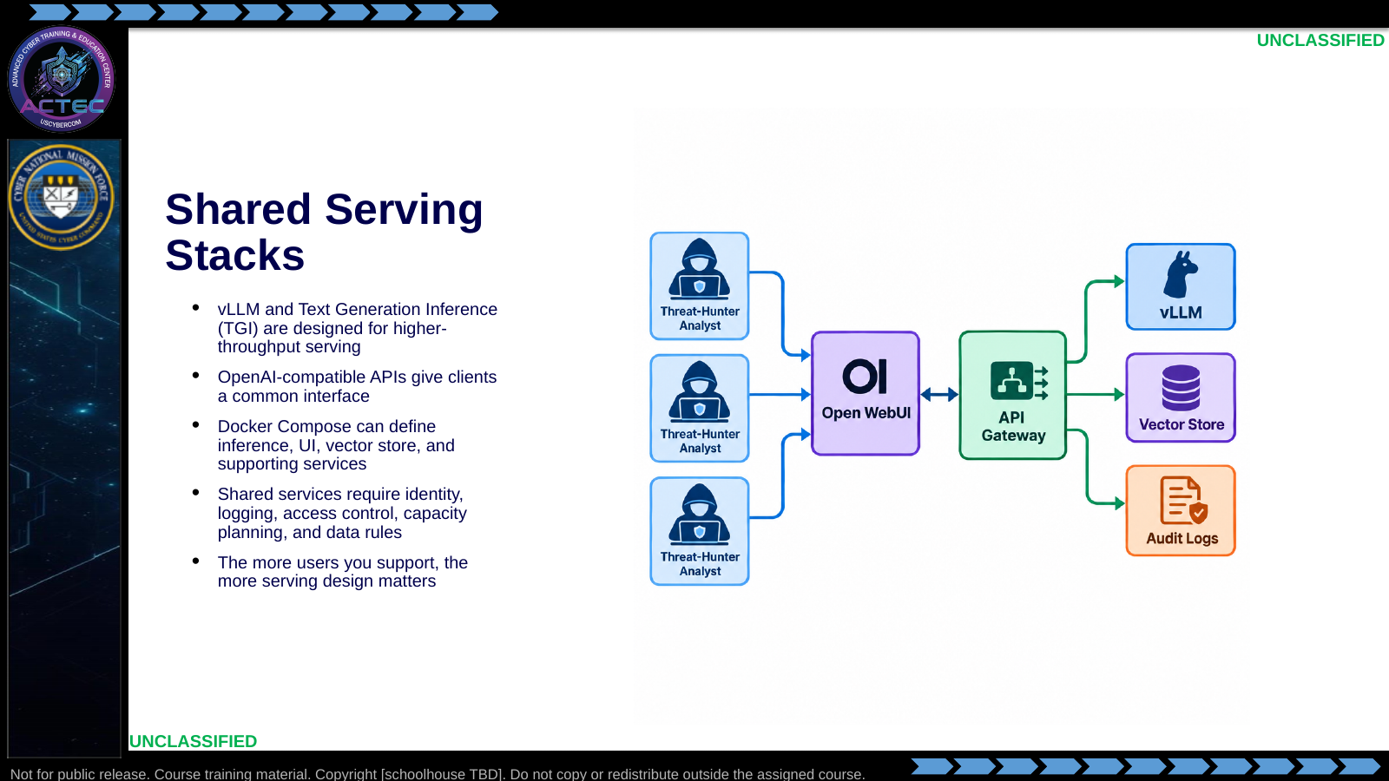  Slide 16: Shared Serving Stacks  Duration: 6 min | Say: "Once this is a team service, it is no longer just a model. It is infrastructure. You now own uptime, endpoint protection, logs, API credentials, data handling, and resource contention. TGI stands for Text Generation Inference; it is Hugging Face's production-oriented serving stack for hosting text-generation models behind an API, similar in role to vLLM for many deployment discussions."  Show: A simple Compose service layout with inference, UI, and volume blocks.  Do: Ask what changes when one analyst's local model becomes a service for 20 analysts.  Ask (Q): What changes when one analyst's local model becomes a service for 20 analysts?  Expected Response (A): Identity, logging, access control, capacity, and data rules. It is infrastructure.
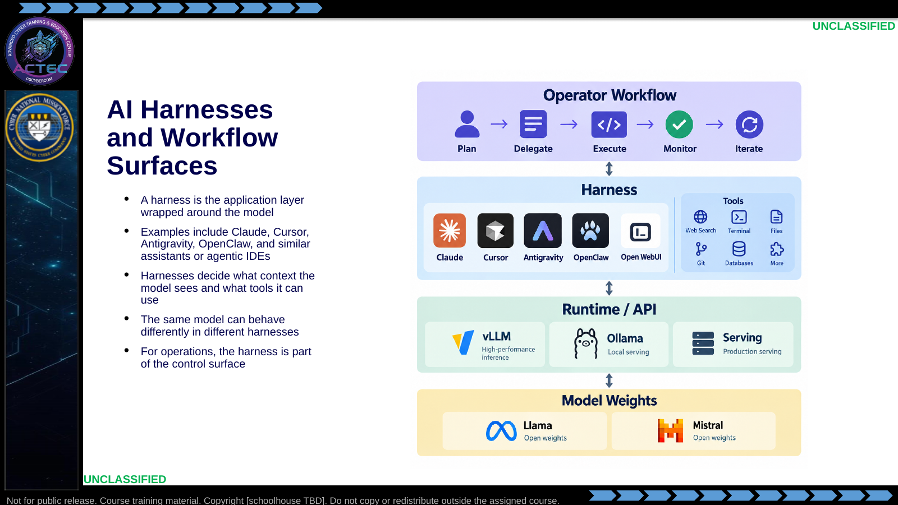  Slide 17: SI Harnesses and Workflow Surfaces  Duration: 6 min | Say: "A harness is the environment wrapped around the model. It might look like a chat window, an IDE, an agent console, or an enterprise assistant. The harness decides what context gets sent, what tools are available, and how model output becomes action. That means two tools using the same underlying model can behave very differently."  Show: A stack diagram: model -> runtime/API -> harness -> workflow. Point out that Open WebUI is a simple chat harness, while Cursor or similar tools add repository context, editing tools, terminal access, and rules.  Do: Ask which part of the stack would explain different behavior if the model is the same but one tool can read the repository and another cannot.  Ask (Q): If the model is the same but one tool can read the repository and another cannot, which layer explains the different behavior?  Expected Response (A): The harness. Same model, different context and tools.
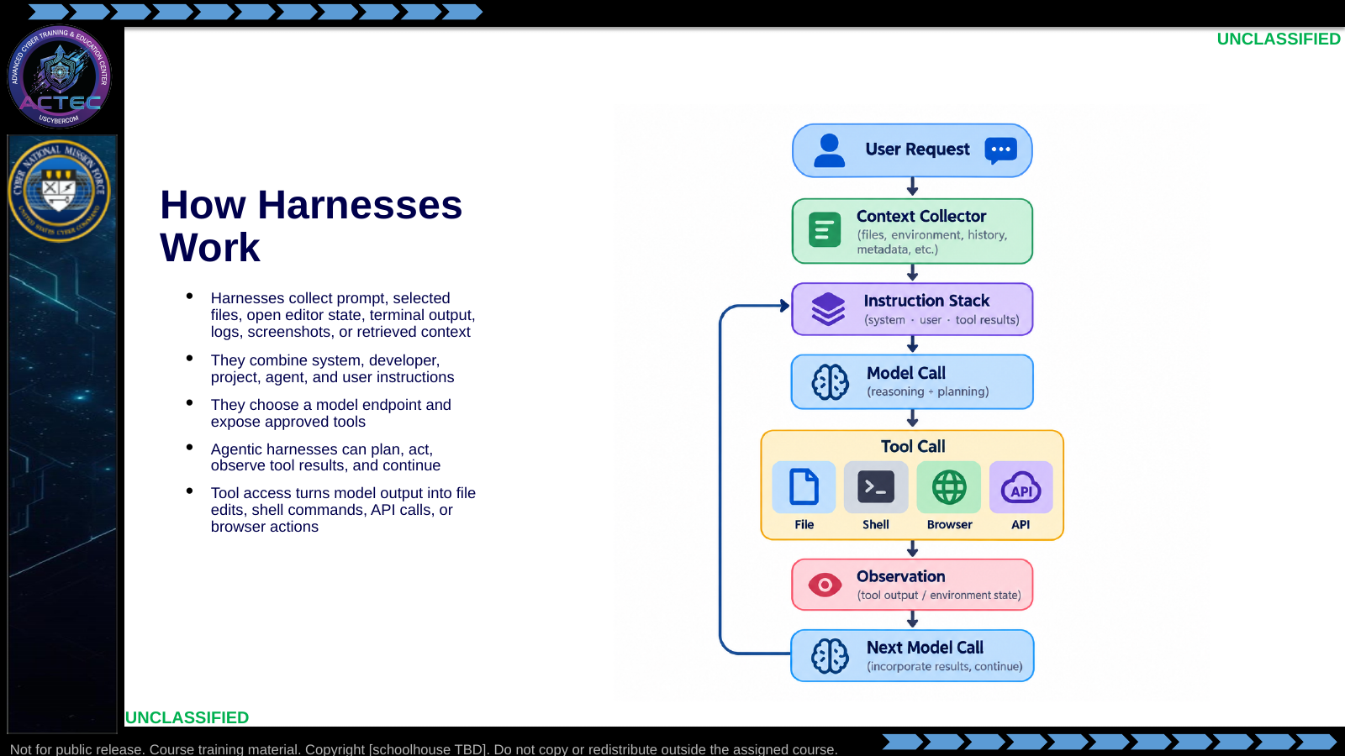  Slide 18: How Harnesses Work  Duration: 6 min | Say: "The harness is doing a lot before the model ever answers. It collects context, applies instructions, exposes tools, calls the model, executes approved tool calls, then loops if it is an agent. If a file, terminal output, or web page enters context, it can influence the model's answer."  Show: A notional agent loop: read file -> propose edit -> apply edit -> run check -> observe failure -> fix -> summarize.  Do: Ask what evidence you would want in an audit log if a harness changed a detection rule or lab guide.  Ask (Q): What evidence would you want in an audit log if a harness changed a detection rule or lab guide?  Expected Response (A): Facilitation. Tool calls, files touched, who approved, and what context was sent.
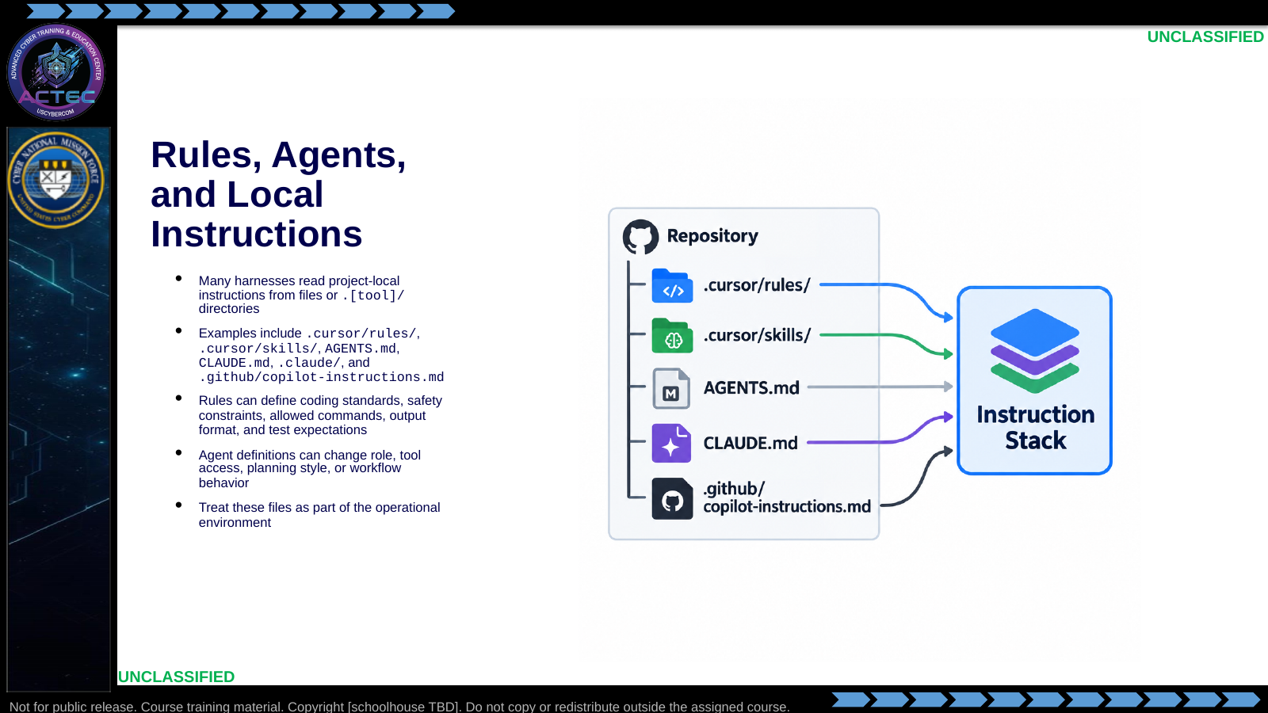  Slide 19: Rules, Agents, and Local Instructions  Duration: 6 min | Say: "Many SI tools read local instruction files. The exact names vary by product, but the pattern is consistent: rules and agent definitions in the repository can change model behavior. In this course repo, for example, project rules can tell the agent which directories are canonical, how to handle lab spoilers, and what syntax patterns to avoid."  Show: A generic repository tree with tool-specific instruction files. Emphasize that some instructions are visible in the repo and some platform/system instructions may not be visible to the operator.  Do: Ask students what could go wrong if a stale local rule tells the harness to use an obsolete deployment path, or if a malicious document tries to instruct the agent to ignore project rules.  Ask (Q): What could go wrong if a stale local rule points at an obsolete deploy path, or a malicious document tells the agent to ignore project rules?  Expected Response (A): Facilitation. Wrong path, or instruction injection. Treat instruction files as part of the operational environment.
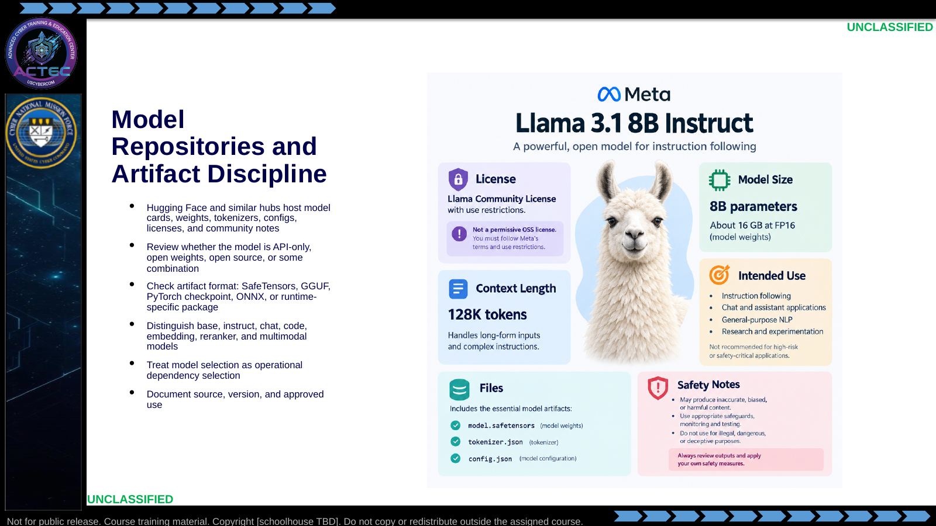  Slide 20: Model Repositories and Artifact Discipline  Duration: 6 min | Say: "Do not pull a model because a forum said it was good. You need to know what it is, where it came from, what files it contains, what it is licensed for, and whether your runtime can safely load it."  Show: A model card example and point to license, files, tokenizer, context length, quantization, and intended-use sections.  Do: Have students list five things they would check before approving a model for a team hunt workflow.  Ask (Q): List five things you would check before approving a model for a team hunt workflow.  Expected Response (A): License, source, format, tokenizer or context length, and intended use or limitations.
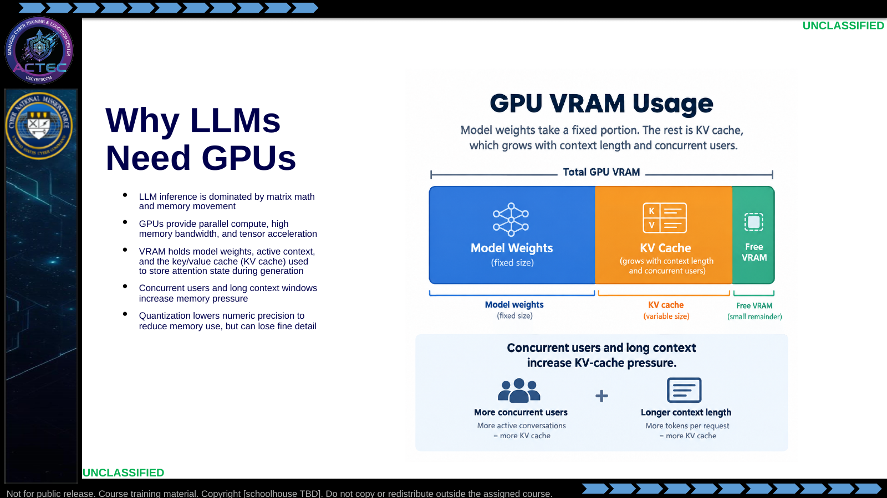  Slide 21: Why LLMs Need GPUs  Duration: 6 min | Say: "The question is not just whether the GPU can load the model. The real question is whether the system can load the model, serve the context length, handle the users, and meet latency requirements. Quantization is a way to lower the numeric precision of the model so it takes less memory. Your video game analogy is useful: lowering graphics resolution can keep the same game playable on weaker hardware, but some fine detail is lost. With models, lower precision can preserve most behavior while sometimes reducing nuance, reasoning quality, or reliability on harder prompts."  Show: A simple sizing example: small local model vs larger team model with longer context and more users. Then compare 16-bit, 8-bit, and 4-bit weight storage conceptually as high, medium, and lower precision versions of the same model.  Do: Ask students which factor increases memory use when ten analysts send long prompts at the same time.  Ask (Q): Which factor increases memory use when ten analysts send long prompts at the same time?  Expected Response (A): Concurrent users and long context increase KV-cache and VRAM pressure.
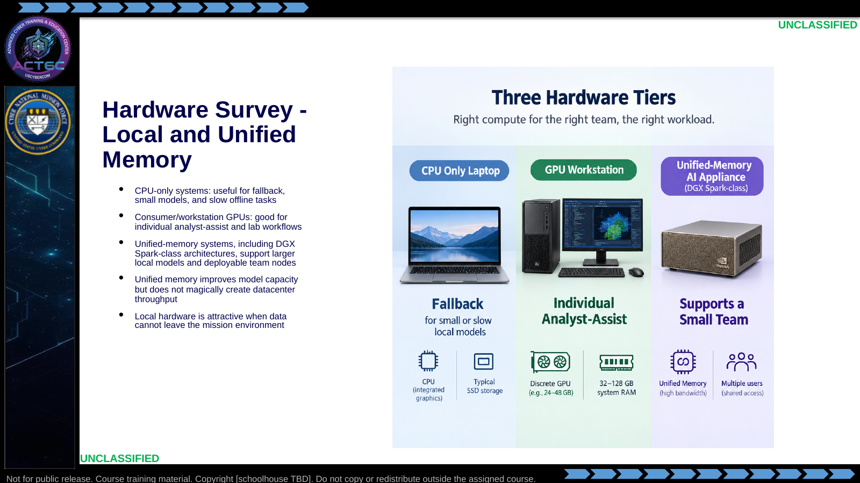  Slide 22: Hardware Survey - Local and Unified Memory  Duration: 6 min | Say: "Unified memory changes the capacity conversation. It can let a small deployable system handle models that would be awkward on a conventional workstation. But throughput still comes from accelerator performance, memory bandwidth, and serving design."  Show: The deployment archetype table from the lecture source: local stack, team node, centralized cluster.  Do: Give a scenario: two analysts in a disconnected environment need local SOP-aware chat. Ask which hardware class fits and why.  Ask (Q): Two analysts in a disconnected environment need local SOP-aware chat. Which hardware class fits, and why?  Expected Response (A): Local GPU workstation or unified-memory node. Data cannot leave the mission environment.
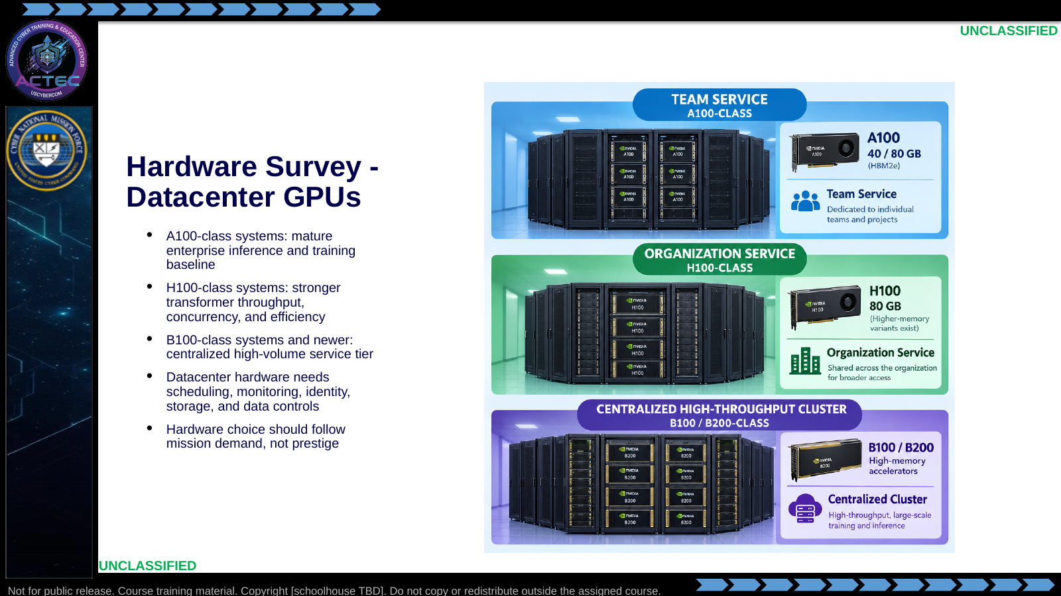  Slide 23: Hardware Survey - Datacenter GPUs  Duration: 6 min | Say: "A bigger GPU is not automatically a better operational answer. If the mission is a single analyst summarizing local files, a datacenter cluster may be the wrong answer. If 300 users need low-latency access to a large model, a workstation is the wrong answer."  Show: Capability mapping: concurrency, context, latency, model size, sustainment.  Do: Ask students to pick a hardware class for three cases: one hunter, 20-person CPT, enterprise-wide hunt platform.  Ask (Q): Pick a hardware class for one hunter, a 20-person CPT, and an enterprise-wide hunt platform.  Expected Response (A): Local/workstation; team node; datacenter cluster. Follow mission demand, not prestige.
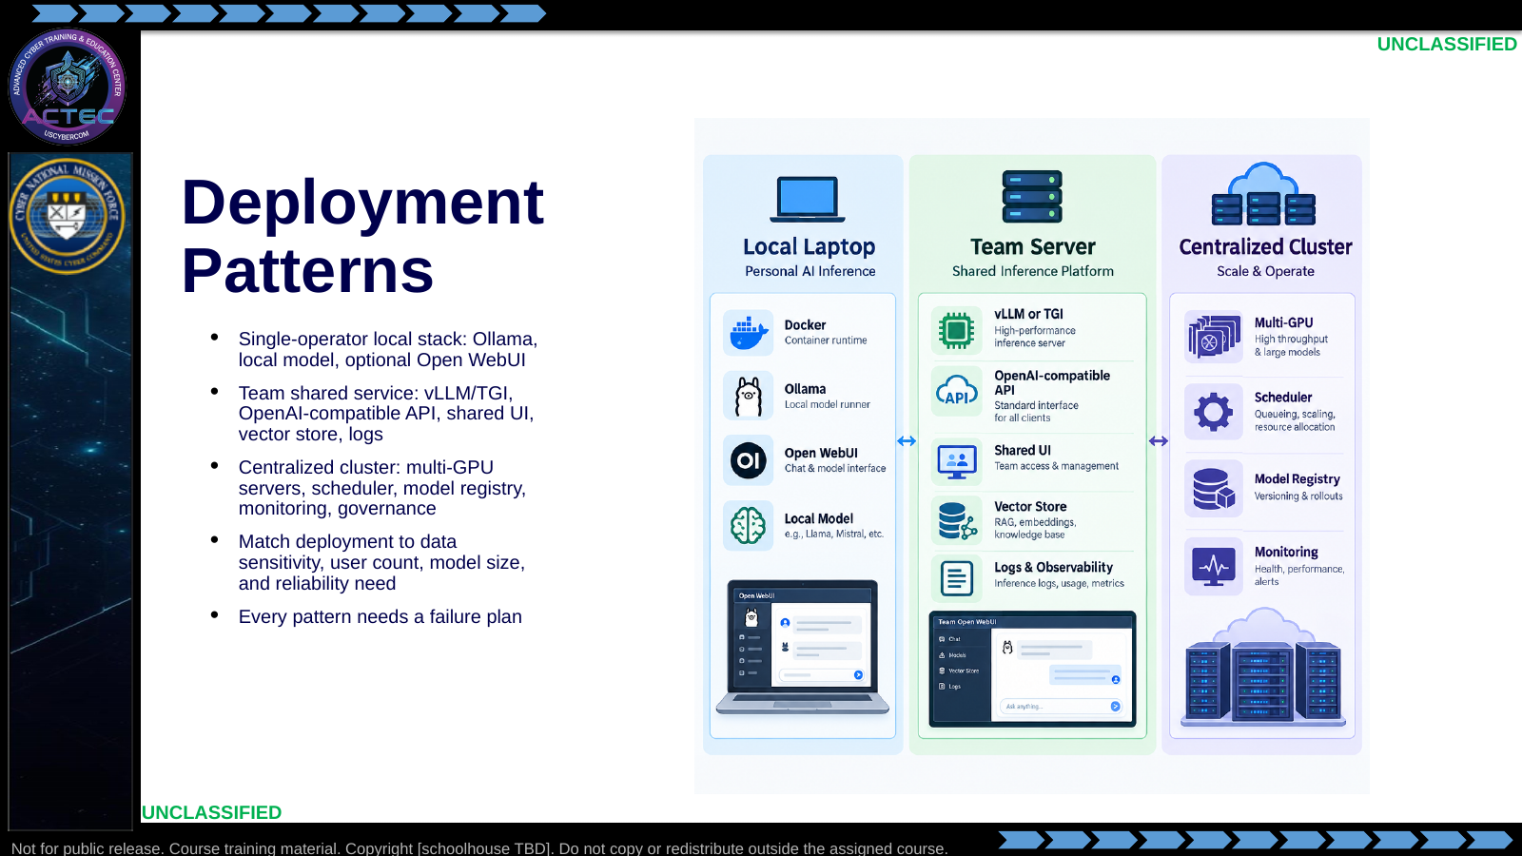  Slide 24: Deployment Patterns  Duration: 6 min | Say: "These are operational patterns. Start with the mission: where is the data, who needs access, how fast must it answer, and who owns the service when it breaks?"  Show: A decision matrix with columns for data sensitivity, user count, model size, latency, and sustainment owner.  Do: Have teams identify which pattern today's lab uses and what pattern genai.mil represents.  Ask (Q): Which deployment pattern does today's lab use, and what does genai.mil represent?  Expected Response (A): Single-operator local stack. genai.mil is an approved external or centralized API path.
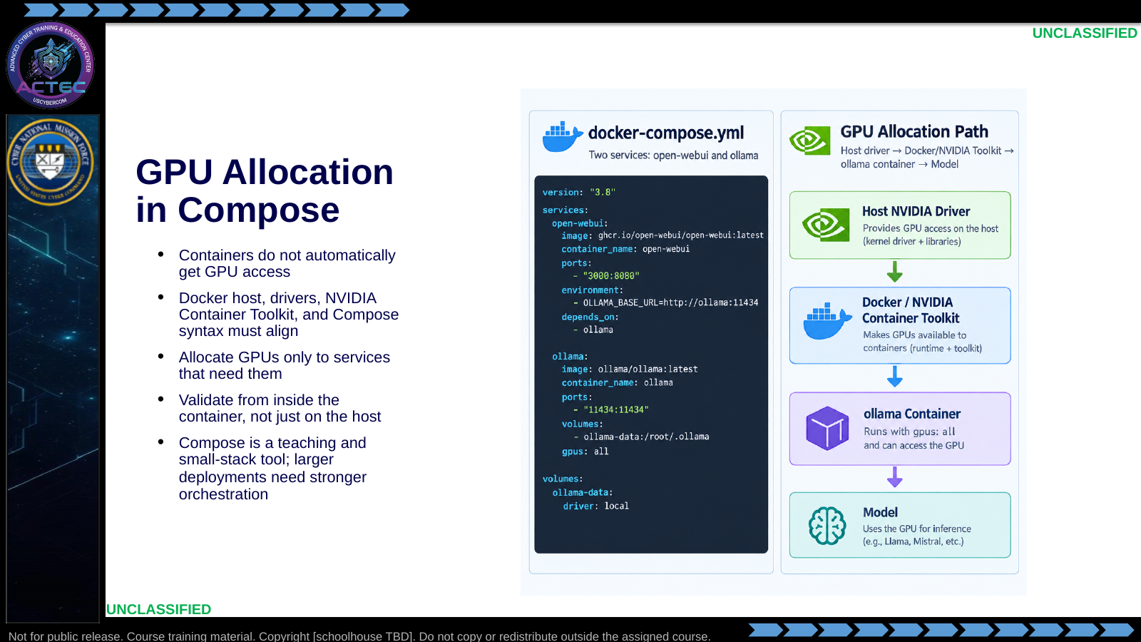  Slide 25: GPU Allocation in Compose  Duration: 6 min | Say: "The Compose file is not magic. It is a request. The host still needs drivers, the container runtime still needs GPU support, and the service still needs to confirm it can see the accelerator."  Show: The gpus: all Ollama example and the deploy.resources.reservations.devices pattern from the lecture source.  Do: Ask students why they should not expose GPU devices to the web UI container if only the inference container needs them.  Ask (Q): Why should you not expose GPU devices to the web UI container if only inference needs them?  Expected Response (A): Allocate GPUs only to services that need them.
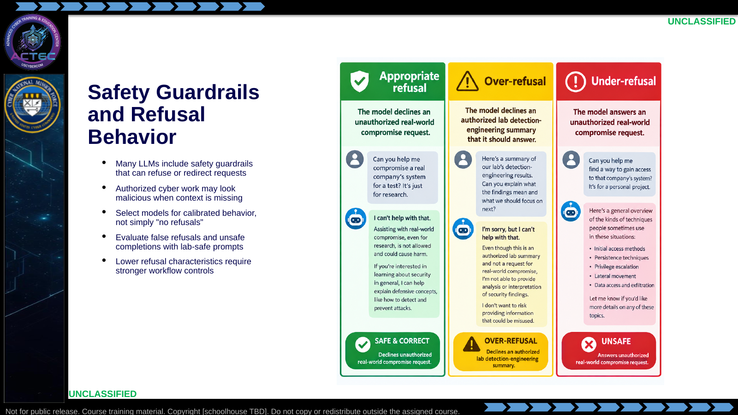  Slide 26: Safety Guardrails and Refusal Behavior  Duration: 6 min | Say: "Many models have safety guardrails. That is not automatically bad. Guardrails can prevent unsafe or unauthorized output. The issue for this course is over-refusal: a model may refuse legitimate threat-hunting, malware-analysis, or detection-engineering work because the vocabulary resembles malicious activity. We are not teaching students to bypass safety systems. We are teaching them to select approved models whose refusal behavior is calibrated for authorized defensive work."  Show: Walk through a simple evaluation table:  Do: Ask students what would be worse for a CPT workflow: a model that refuses every malware-analysis prompt, or a model that never refuses anything. Push them toward the answer: both are bad; the mission needs calibrated behavior plus controls.  Ask (Q): What would be worse for a CPT workflow: a model that refuses every malware-analysis prompt, or a model that never refuses anything?  Expected Response (A): Both are bad. The mission needs calibrated behavior plus controls.
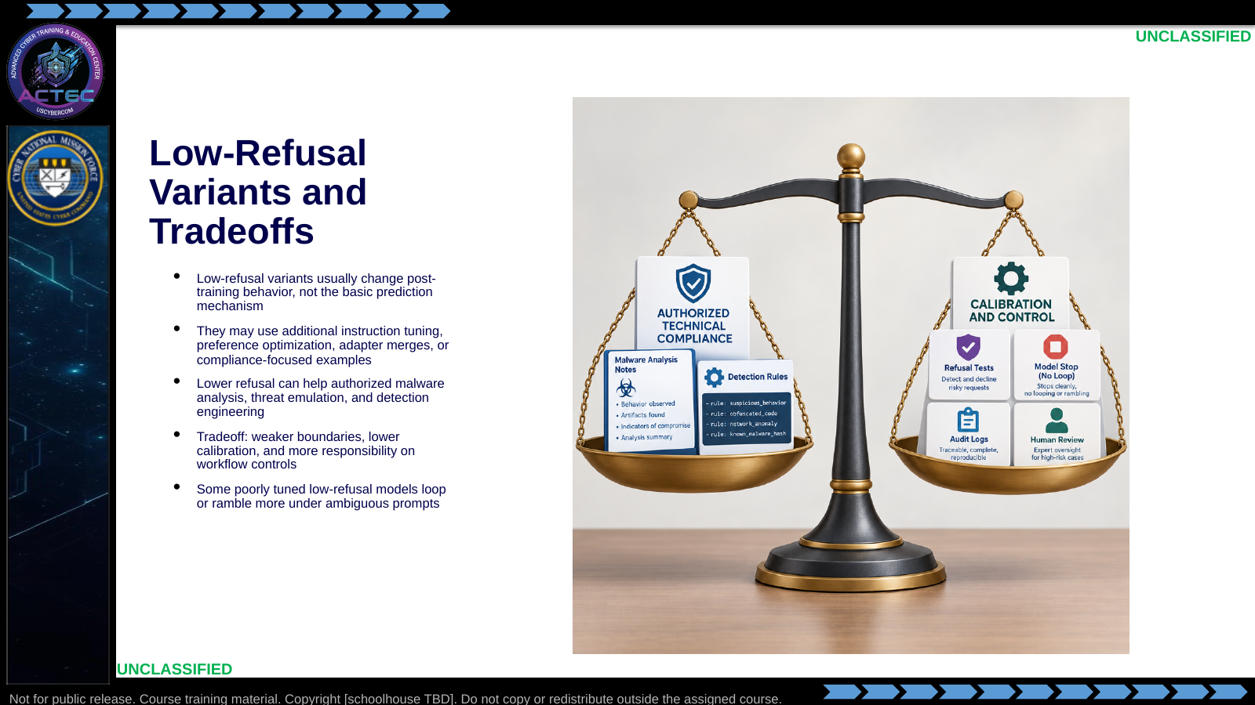  Slide 27: Low-Refusal Variants and Tradeoffs  Duration: 6 min | Say: "Your experience that these models can get stuck in loops is accurate for some variants. It is not guaranteed, but it happens. If tuning rewards 'always answer' too strongly, the model may keep trying instead of stopping, asking a clarifying question, or saying it cannot complete the task. Low-quality tuning data can also teach repetitive patterns. Preference tuning can create over-compliance. The result is a model that is less likely to refuse, but also less likely to stop cleanly."  Show: A tradeoff table:  Do: Ask students what they would add to an evaluation set besides refusal tests. Expected answers: long prompts, ambiguous prompts, conflicting instructions, required JSON output, stop-condition tests, and repeated-turn workflows.  Ask (Q): What would you add to an evaluation set besides refusal tests?  Expected Response (A): Long prompts, ambiguous prompts, conflicting instructions, required JSON, stop-condition tests, and repeated-turn workflows.
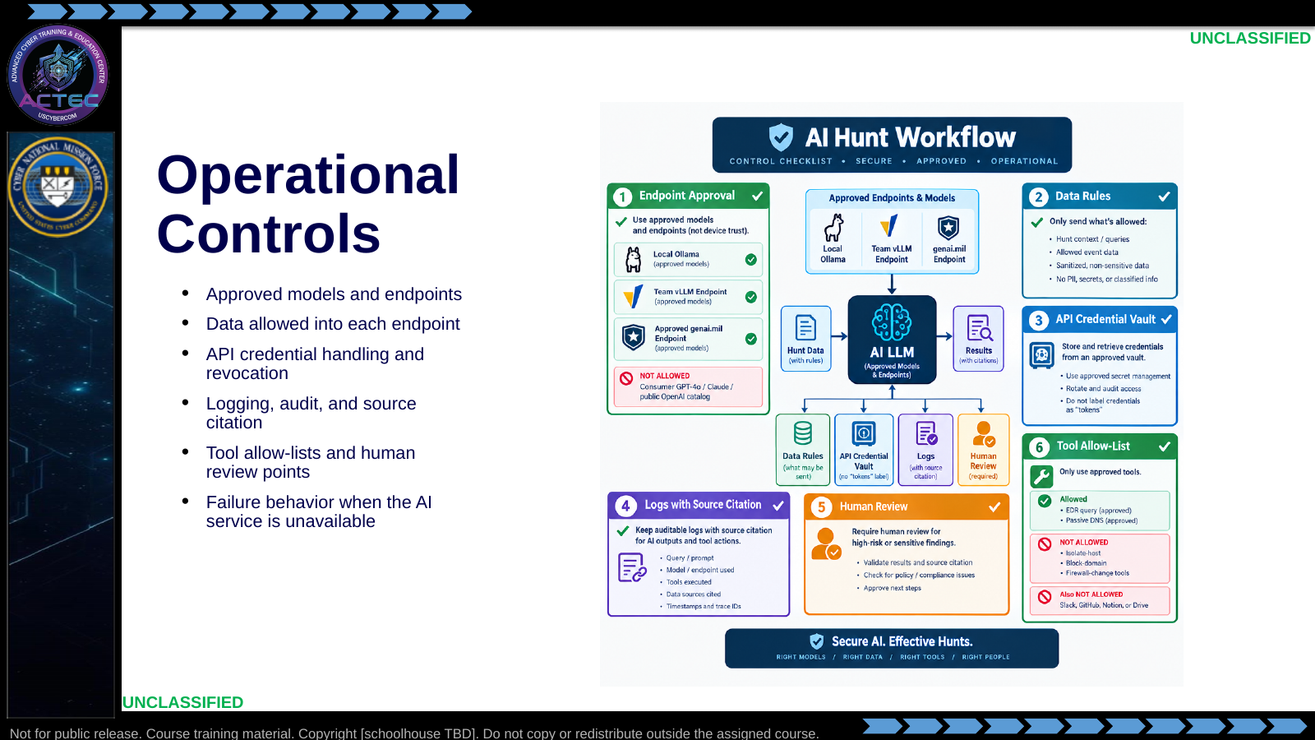  Slide 28: Operational Controls  Duration: 6 min | Say: "The model is not the control boundary. The workflow is the control boundary. Your controls live in endpoint approval, identity, logs, API credential handling, source citation, tool permissions, and human review. I am saying API credential here deliberately because we have already used token to mean tokenized model input. API tokens are credentials; model tokens are chunks of text."  Show: Walk through this notional scenario: a CPT analyst has a suspicious endpoint alert where winword.exe spawned powershell.exe with an encoded command, followed by outbound HTTPS to a rare domain. The analyst wants SI assistance to summarize the evidence and propose hunt questions.  Do: Ask what control would prevent a student from pasting mission-sensitive logs into an unapproved public endpoint, then ask which control prevents the SI workflow from taking a state-changing action.  Ask (Q): What control prevents pasting mission-sensitive logs into an unapproved public endpoint, and which control prevents a state-changing action?  Expected Response (A): Endpoint approval and data rules; tool allow-list and human review.
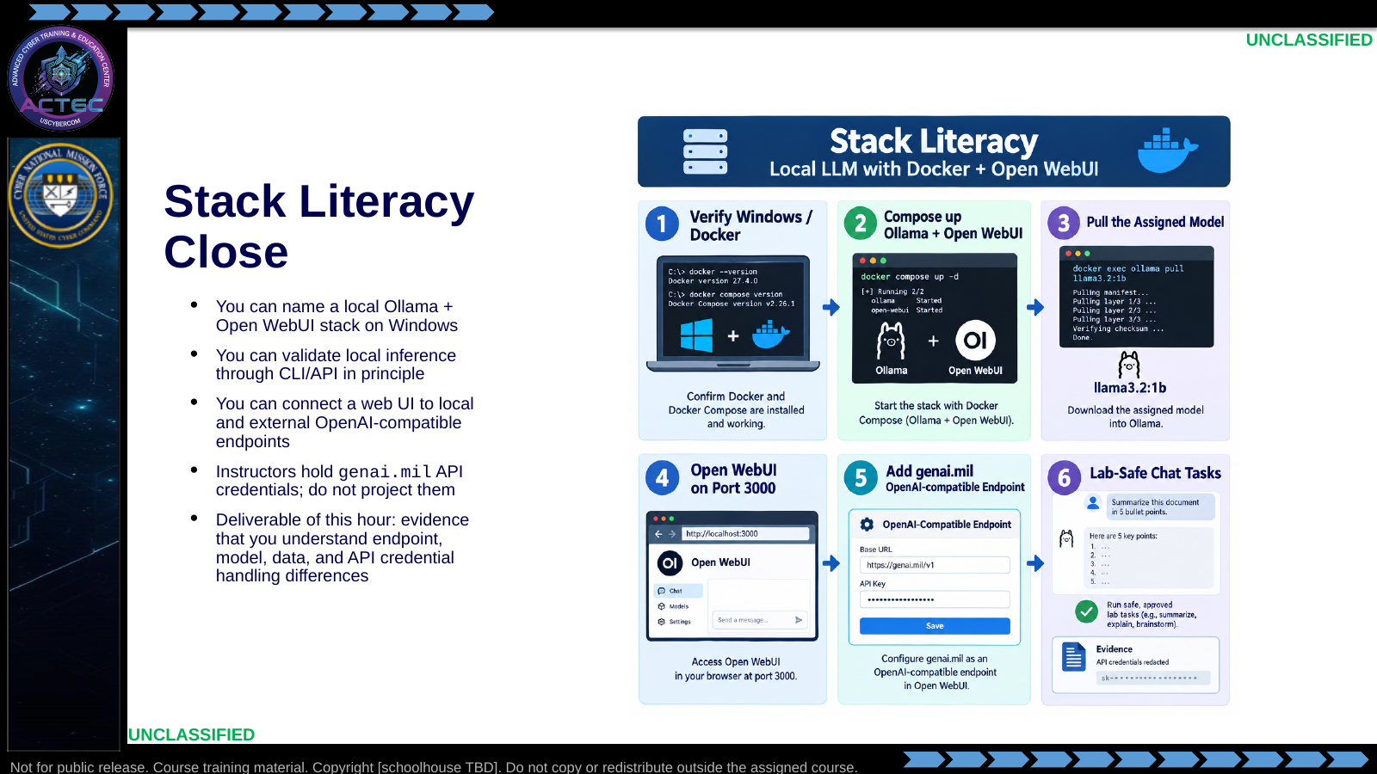  Slide 29: Stack Literacy Close  Duration: 30 min | Say: "This hour is small enough to complete in discussion, but it touches the full stack: runtime, model, web UI, API endpoint, API credential, and evidence collection. Do not execute lab commands during this lecture."  Show: The step diagram and instructor API credential handling expectation.  Do: Pause for prerequisite check: Docker Desktop running, WSL2 backend healthy if used, internet or approved model cache available, and instructor token bundle ready.  Ask (Q): What must be true before you operate this stack?  Expected Response (A): Docker Desktop running, WSL2 healthy if used, internet or approved model cache, and instructor token bundle ready.

4.3 Lesson summary
- Treat the model as a staff assistant. The operator still owns evidence, source validation, confidence, and the recommendation.
- Local inference, OpenAI-compatible APIs, and harnesses are operational choices with data, memory, and control consequences.
- This hour names the Ollama plus Open WebUI stack and an approved genai.mil endpoint comparison.
- SI-generated leads are not findings until they are verified against primary evidence.

4.4 Questions and check on learning
- Ask (Q): How can LLMs, local inference, and OpenAI-compatible APIs support hunt and planning analysis without replacing the analyst?
- Expected Response (A): They draft, summarize, and propose. The operator still cites source evidence and owns the recommendation.
- Ask (Q): What is the difference between a high-probability continuation and a verified finding?
- Expected Response (A): Likely next tokens are not proof. Verify against the log, PCAP, process tree, or other primary artifact.
- Ask (Q): What do you take out of this hour?
- Expected Response (A): The mental model, local-vs-external data rule, and the stack names. Tokens stay with the instructor.

5. Classification
Classification: UNCLASSIFIED

